Greek Pottery
Name
Institution Affiliation
Course Title
Date

Introduction
The Greek pottery of ancient times started between the years 1000 to 400 BCE. The Greek pottery is comprised of some definite vase shapes which are made from antiquity. Some are also made from the earliest and most different representations from the cultural beliefs as well as the cultural practices of the people. Pottery is believed and has been seen to be so durable even though it might undergo breakages but even in that state it has still been seen to be extremely durable. Greek pottery is recorded as an essential tool for all the archaeologists as well as historians in the determination of the chronology that is associated with the ancient or long time Greece. The material that was used by the Greeks to produce this pottery was the clay which was easily accessible in the country. The clay was well prepared and refined than later on settled in tanks so that they could achieve the consistencies of all the materials used that is depending on the vessel type used.
However, both the painter and the potter had a kind of unison in those ancient times. This is because they all depended on each other in that the potter had to make some pottery so that the painter could get some work. The four different kinds of Greek pottery are geometric, red-figured designs, black-figured designs and the Corinthian style (Barringer, 2015). To begin with, the perfume flask is an example of one pottery which existed in ancient times in Greek. Majorly, the perfume flask existed during the Geometric period. From this perfume vessel, some stylistic features have been portrayed. Firstly the style of the paintings which have been used here. The painter drew some duck-like birds, a horse and other more calibration. This was purposely to beautify the vessel and make it look more cultural.
The main aim of painting any kind of pottery is to make sure that it bears some meaning apart from the sense of decoration. The perfume vessel has also been made in to be pot-like and that is to allow it to accommodate something either a liquid inside it. It also bears some wooden handles, which signifies culture and also makes the perfume vessel more beautiful. Pottery, paintings are all part of the art. All this depends on the natural talents of every individual. Therefore with the collaboration of all these three different personals, the work of pottery has improved. It is also clear that no pottery work can be perfect without paintings, therefore they are very key in marketing the goods.
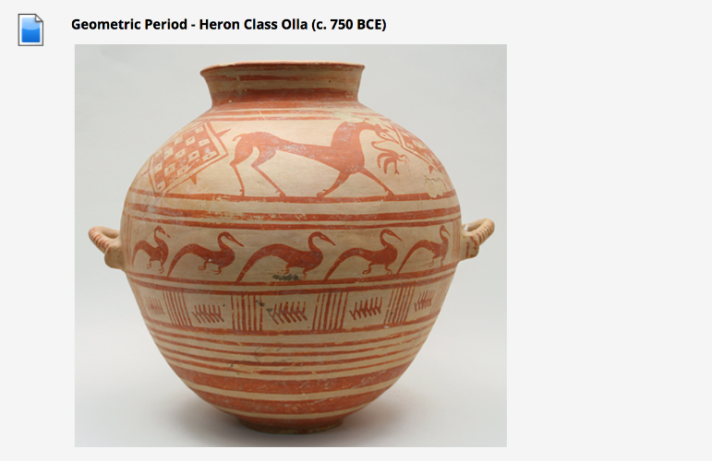
Another work of the ancient Greek pottery was the Orientalizing perfume vessel. Just like the way the geometric period vessels were painted, so is the pottery work of the Orientalizing period. The vessel paintings in the Greek pottery work especially the Orientalizing perfume vessel display both the human as well as the mythological activities. Some of the vessels that were made since the Greek pottery age that is so many years old. They were used for some activities such as fetching water from the fountain house in exchange for heroic deeds. During the period of Orientalizing, the pottery of Greek, as well as art, evolved and developed fast featuring a mixture of the close eastern as well as the stylistic conventions of the Egyptians.
The Orientalizing period existed between the year 700 to 600 BCE. In this time other cultures were influencing the Greek culture in the making of pottery artwork. They also experienced some international influences from the old near East, the Asian Minor, and Egypt whereby all of these countries had an impact on Greek art. The extent of the closeness between different cultures increased due to trading factors and colonization as well. They were some pottery work objects which were then developed due to the mixing of different cultures. Also in the Orientalizing period, there was no making of figures of human images. Instead, figures were made of animal images such as the griffins, lions, sirens as well as the sphinxes. The patterns which were used to fill empty spaces were the lotus blossoms and the palmettos. All this was happening due to cultural influences to the Greece pottery art which was also aimed at improving it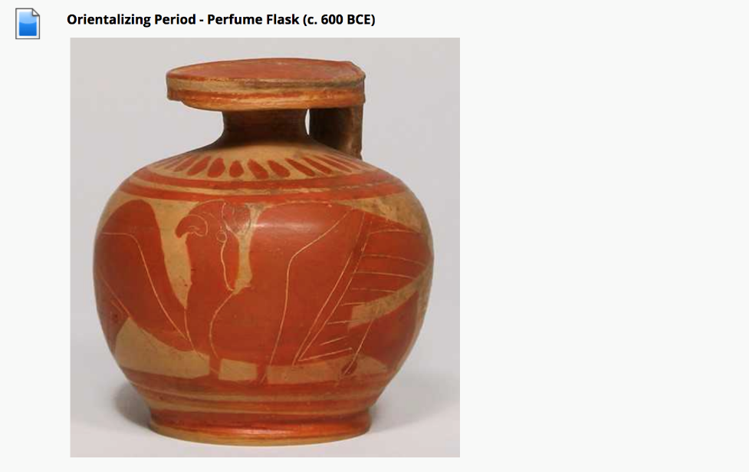
The black-figured painting techniques were developed by a Corinthian also during the period of Orientalizing. The black-figured painting techniques were remarked by the introduction of the mythical and some exotic animal breeds. The style later spread widely in Greece and later, unique Greek images were formed by the artists. In the black-figured painting style, some figures were painted unto the pot using a slip which when fired it would be turned black. All the figures were usually incised on the vessels before actual firing. Some extra white and red pigments could also be added to the pot. The vessels had slips of black color, and red pigments could also be added for a more color so as they could differentiate the details. This style widely spread and changed the subject matter from the Near Eastern animals to scenes which they had obtained from Greek mythology and their daily life.
Another different kind of painting and pottery method which was used included the proto-attic pottery period. This kind of pottery refers to vessels that were produced in Athens as well as in the surrounding regions. This particular style was remarkable due to the extensive use of orange-colored clay. Some other factors which made this kind of pottery remarkable were the presence or making of the simple human forms and also the early depictions of the mythological scenes in the painting of the vessels. The bodies of human figures and animals were depicted in the silhouette although they had their heads drawn particularly in outline even for women bodies. The clay used for this kind of painting was only available for the attic ceramicists.
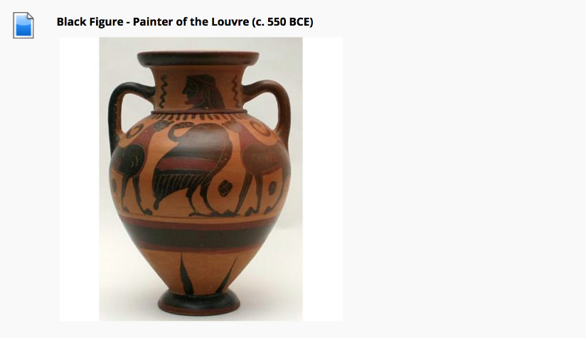
Another different era of the Greek pottery development was the archaic period. It refers to the earliest cultural phases. It signifies a certain period of artistic development in Greek which occurred between the years 65o to 480 BC. During this period it is stated that the art in Greek became more naturalistic and less rigidly stylized. Some of the paints which were represented apart from the human figures signified old epic tales. This artwork represented the growing concern with the harmonious proportions of architecture. Some of the painters who occurred during this era such as Amasis the painter were responsible for decorating various black-figure two-handled jars. The archaic ancient period of Greek was majorly influenced by the cultural practices of the area during that period. The potters, as well as the painters, therefore tried to imitate the culture.
The red-figured technique was used in the fourth and fifth centuries B.C. the red-figured technique is also referred to as the classical period in the Greek pottery. This red-figured technique was highly influenced by the political conflicts in Greek. After a good time, pottery and artistic work gained some sense and respect after the construction of the temple of Doric. This temple was highly decorated with sculptures. The establishment and decoration of this temple with the sculptured bared a great impact on the artistic work. Some sculptures were made from bronze although they did not survive for a good period of time. During the fifth century, the classical period or the red-figured technique outdid the black-figure technique and superseded it.
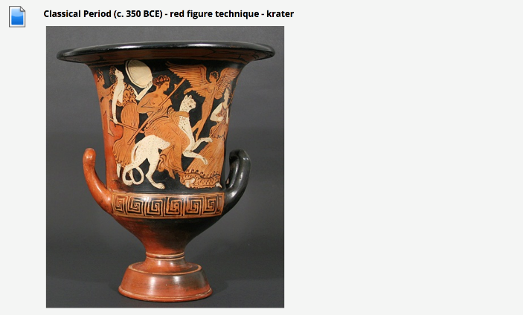
Some of the artistic work which was developed using the red-figure technique included human body images, either dressed up or naked images, some were made to be at rest and others were made to be in motion. This era did not go for a long time as it was affected by the war of the Persians. There were also many more designs of the human images which were made. Other different styles of sculptures were made and kept at the Olympia temple in Zeus. From this era, many sculpt were developed. They were all made based on the culture of that age whereby some were made as images of the ancient leaders.
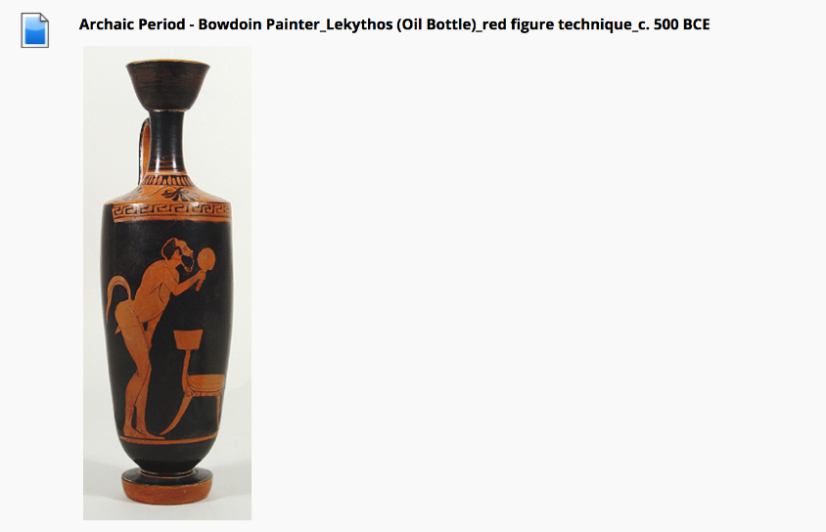
Conclusion
Following the visit to Lowe Art Museum, Greek pottery was notably seen to be of good value and importance to the people of the ancient times as well as in the current world. Firstly, during the many different periods of pottery work, the people of the ancient times used pottery as their way of storage. They stored everything ranging from wine to wheat in the decorated pots. However, as time went on, it became a source of income to many who had ventured into it since the artwork was used to decorate temples and make sculpts. The Greek pottery also has historic importance of the country in that it made the country well known due to the diversity of venturing into the art and pottery work. Lastly, it was also important to the country and all the communities in Greece for the preservation of their culture.

Reference
Barringer, J. M. (2015). The art and archaeology of ancient Greece. Cambridge University Press.
Nevett, L. (2017). Theoretical Approaches to the Archaeology of Ancient Greece: Manipulating Material Culture. University of Michigan Press.

